Cover Letter

Dear sir or madam from ***Artefact Korea:***

How are you?

I am David Ding, a guy with developing, consulting and leadership experience in ***Digital Marketing*** and ***Martech***, located in Shanghai China. Nowadays, from my view, especially for the international brands in china, daily increasing marketing requirements push the Martech Industry to evolving urgently. When I touched your company site, it was really amazing that your team insights and ideas indeed surprise me a lot. And I’m sure that Artefact is the ideal company where I want to work, make some of my Ideas come true and help company achieve more market share if there is any chance. Except that, I am pretty interesting about the opportunity ’Consulting Director’ that posted here on Greenhouse.

And for you sir, the startup leader of ***Artefact Korea***, I know that you just newly start up ***Artefact Business*** and is longing for good talents who not only have capabilities on data, digital marketing but also willing to take the very burden of the startup phase. Although, I am located in Shanghai. It is not an obstacle for me to relocate in Seoul. I am single till now and is an enthusiastic guy so that I could relocate without any other concerns. I do love the business and tech of data digital marketing. If you sir have strong interest in me and don’t mind bringing me in from China. I hope you sir could take me as a consideration. There is an old Chinese saying that a swift horse need a Bole who is good at recognizing talented horses to be his master. I hope you sir could be my Bole. Thanks anyway.

I worked for ***Dentus Merkle***-A Data Driven Precise Marketing Agency and ***Impact Radius***-A Partnership Marketing Automation SaaS Provider (Affiliate Platform) for 7 years. And as below, I’d like to share my ideas so that I will pick up three ideas to share from my past experience and thinking, I hope it is helpful for you sir to start up the team.

# Nowadays Marketing Nature

About Nowadays Marketing, I think a common thinking way is as below.

* **Choose Right Audience**
  + Model on user data including but not limited, CRM data, Web Analytics data, DMP data to figure out the right user segments, and tag, describe the feature or the user segments
* **Raise Right Campaigns**
  + Prepare special campaigns for the certain user segments and raise it
* **Find Right Touchpoints**
  + Find best channel practice, either inner or outer clients eco-system, to push the campaign to the certain user.
* **Achieve Predictable Goals**
  + Clients monitor the dashboard to check if achieve the predictable goals
* **Do Again Better with Optimized Cost**
  + After once of the cycle, clients gather more and more users’ data and could do more precise decisions with modeling and analytics on updated data to get a higher ROI

# AI-Driven Marketing Automation

## Painful Points

Brands like ***Estee Lauder***, ***NBA China***, ***AIA China*** have diverse demands on data vision and marketing strategy. Some common demands are as below:

1. **Marketing Dashboard For Monitoring** – Generating daily, monthly, yearly report from dimensions of products, campaigns, sales, traffic with ***CRM*** and ***Web Analytics*** Data Source.
2. **BI Reporting for Optimizing Channel Marketing Strategy** – Digging Deeping in data with BI tool and Pivot Tables to have a well-telling story helping make channel strategy better.
3. **Data Application Back to Channel and Commerce Ends In Time** – Segmenting out right audience to push right campaigns, drive precise leads, activate consuming desire, keep loyalty and returning buyers.
4. **Integrated All Chains’ Data in Clients’ Business Eco-system –** data integration, modeling on and feedback with data from diverse sourcesincluding online, offline, multi clients’ sites, and third party traffic suppliers to make comprehensive marketing strategies and apply them to next marketing in time and even directly **in an automated ways.**

## Solutions

For current marketing tools and agency that I have known, they can only handle the first two painful with existing main class tool and manual data processing reporting. They are not in a smart, semiautomatic or fully automatic ways to handle these points.

And for the last two points, brand owners themselves will struggle to construct***Data Lake*** ***(CDP)*** and agencies just some partially applied data applications. It is tough for both, because ***Data Lake*** overtakes the human resource, assets, and funds to maintain and gain lower ROI. And I believe that in brand owners’ team, there is few engineer that is so-called ‘data scientist’ and brand owners thus cannot understanding data than an AI&ML team. I think this is a huge advantage of ***Artefact***. That means that I believe ***Artefact*** is the right team who could make the solution mentioned below come true.

### AI Driven Marketing Automation

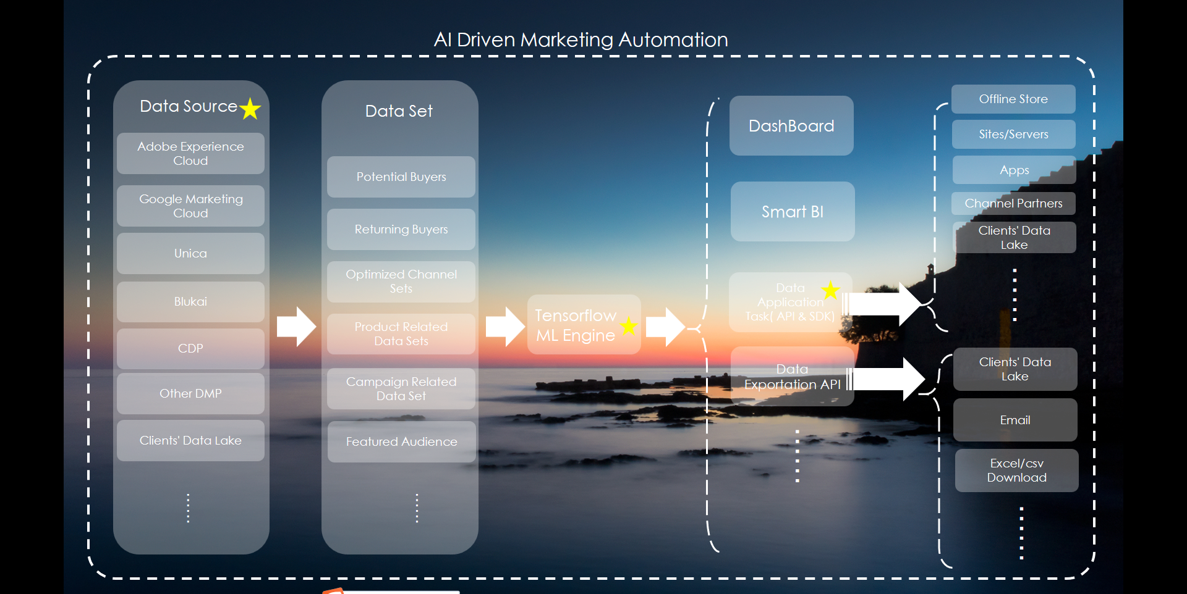

This platform idea to specially aim to solve the painful points and transform complex solutions in nowadays digital marketing area to a commonly-used and best practice with ***Artefact***’s resources for long term.

#### Data Source

Same with most clients’ ***CDP*** or ***Data Lake***, It supports multi data sources for ingestion and integration with database query, API feeds, and file importation from client’s database, ***CRM***s, clients’ Data Lake, third party tools like ***Adobe Experience Cloud, Google Marketing Cloud, IBM Unica, Oracle BlueKa***i and other many ***CDP***s. It integrates these data source ready for creating dataset.

#### Dataset

In Dataset, data scientists create dataset and do data washing, integrate different source raw together and ready for machine learning.

For example, clients want to do near real time recommendation personally to promote second time sales on existing buyer. Data scientist need to integrate data from ***Adobe Analytics*** and clients ***CRM*** with ***UUID***, or client contact info and create a data set for it. Data scientist also need a product data set from clients ***CRM*** and a campaign data set from client databases.

Next step for it, data scientist use these three data set to work out what products customers may need and like, and what products client promote first in clients campaign agenda in short time. Not only about this, client care more about how to apply this workout to online shops, and the workout need to be consecutively updated and near real-time in an acceptable time period range. How to make it? I will describe it next sections.

#### Tensor Flow ML Engine

These part is for data scientist to work out what clients need. In last section, we talk about clients want to promote second time sales on existing customers. Then data scientist need to use ***Adobe Analytics*** data set to work out:

* ***user path***
* ***user behavior***
* ***user’s interest and buying desire score*** from several dimensions like how long has a user been looking at a product detail or campaign page and how many valid interactions has a user done to the special page or product like add to cart, choose color and size, and even customization behavior.

Throughout these score topics to work out **best recommendation practices.** Data scientist could just do coding on platform pages without needs to operate tensor flow and database and save it as a model ready for next step.

#### Multiple Functions in Platform

With models being tested and saved, analysts could just use the models to build functions like **Dashboard**, **Smart BI Reporting**, **Data Application Task API, Data Exportation API and etc.**

With selected models that have been tested and saved by scientist, analyst could:

* Choose the recurring period of how long data source quoted in data set needs updating for each function,
* Set Smart BI Reporting to indicating marketing channel optimization, UX experience suggestions and etc.
* Create dynamic and parameterizable API for clients temporarily and periodically complex usages
* Create Exportation Task in API, SQL query, file download, and Email ways to touching clients’ team.

And then clients could:

* Check the dashboard for daily sales team need and data QA.
* Take the suggestions from Smart BI
* Apply data application conveniently with API or SDK for a shorter lifecycle, to clients’ sites, apps, and offline content displays, third party channels like WeChat, Tiktok, and public and private field traffic.
* Get data which modeled on this platform to do further analytics and application.

## Extra Thinking

Actually, this platform could involve and integrate web analytics, CDP, DMP, and Clients Eco System together to form nowadays evolving marketing automation with core tech AI & ML. I believe it is indeed a frontier and bold idea for these days’ Martech market. Slogan of the idea is “AI Marketing Everywhere”. For clients, there is no need develop more data scientists and marketers could make it easily. For agency, it is a really competitive platform product which could be applied to most of the international brands data environment including retailing, luxury, healthy, insurance, banking, loaning, and etc.

# Performance Marketing SaaS Integrating Both Creative and Marketing Tools.

## Painful Points

Traditionally, Marketing tools and Creative are independently and separately used to push a campaigns. Therefore, so many dashboard tool and BI tool only do data analytics on user data and CRM data and none business with the quality of Creatives. Actually many brands own some external creative partner to generate creative for campaigns. Thus the quality of the creative and creative team’s service could not be leveraged and scored directly in data vision with sales. This limits brands to choose more and better creative teams from external ways.

## Solutions

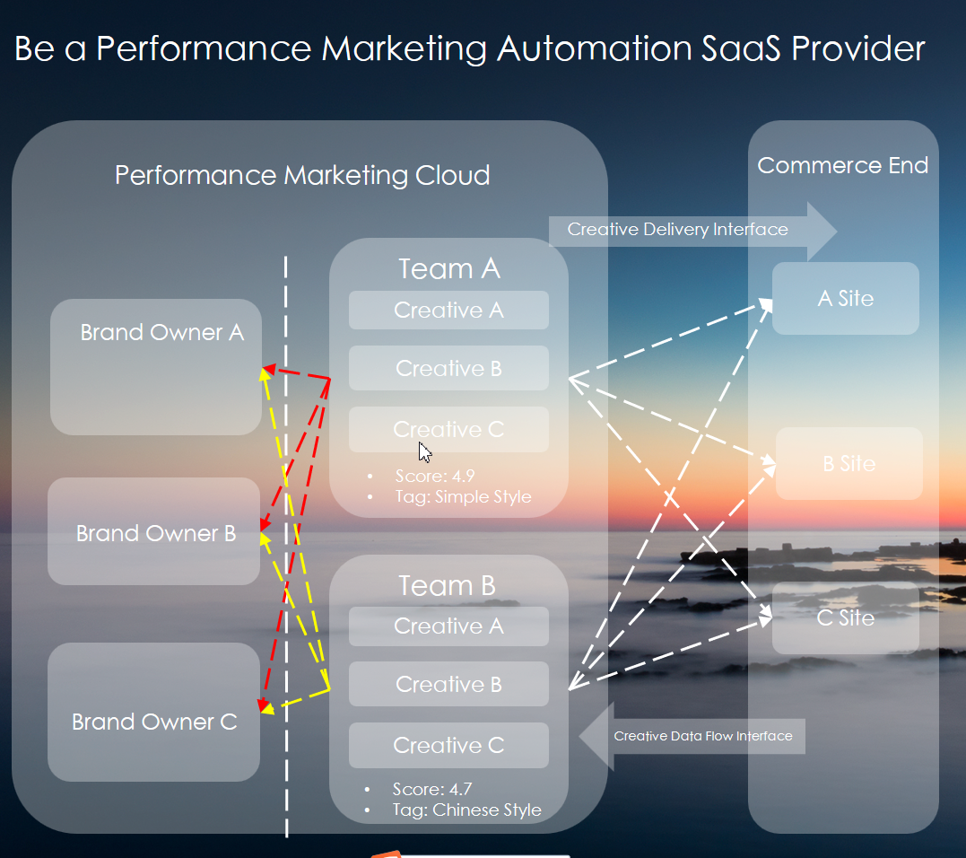

I believe ***Artefact*** has many creative team resources over around the globe and the idea may an aspect of ***Artefact*** development.

This Performance Marketing SaaS is aim to track the data performance including impressions, products, campaigns, orders of every session creative being placed.

Below is the user case of the solution.

1. Brand Owner publish a creative request.
2. Brand Owner filter out several creatives team with AI Engine and launch a sealed **bid** invitation to wait for creatives team giving design **sample, pricing, estimated deadline** andetc.
3. After creatives teams accept bid invitation and complete replying, brand owner **contract** with the best team according to bid info they gives and even the history performance and assessment before.
4. After contract signed, creative team complete production and upload workouts to cloud.
5. If brand owner want to dispatch creatives to channels, he or she could get down a creative file and **tracking links** which is led to destination sites and put these file and links combined together to channels.
6. We **track** the touching data including **who touches the ads**, **the ads creative team**, **the order info** and then process the data to assess the creative team performance in current creative request for the reference in next contract or new brand owner to check and tag the Creative team for easy search.
7. The platform will take the funds from brand owner temporary and pay to the creative teams after the contract closed .We **get percentage up** for the platform service **from the request contract** between creative team and brand owner.

## Extra Thinking

The idea is formed by me when I met a Chinese creative company ***Liquid*** which is now focusing on creative marketing. After it, I find another Chinese company ***Tezign*** having already given the similar solution I mentioned above. I find this is a brand new area not just about data marketing.

From my opinion, data itself is not the value. But data reflect and create value through modeling on many areas of human society information system including vision, creative. Hearing, smelling, touching. So I think the solution is an era new start try for combining data and creative.

# Talk about Me

Here is the familiar fields of mine, only limited to technical and conceptional part and with hand-on development experience:

* **Web Analytics** (user path, user behavior, click heatmap, user profile)
* **Channel Management and Directional drainage** (including inner site and external channel)
* **Data BI Reporting, Data Audit & QA**
* **Affiliate Marketing Automation**(Impact Radius)
* **Data integration and Application** including but not limited, recommendation engine through Data Lake Solution(CDP)
* **MiniProgram, Website, App Development**
* **Java Spring Cloud Project Architecting**
* **Team Management and Agile Project Management**

My Advantages:

* A quite strong technical background consultant and team leader with thinking from both client needs and tech implementation sides.
* Client facing experience with many famous international brand owner like Estee Lauder, NBA and clear knowing and conclusion of clients’ painful points and prospective transformation framework in digital marketing development.
* Owning technical development capabilities and technical project management and ability to gives comprehensive and integrated insights and ideas, in order to promote product development team to create a better products and platform in the industry.
* Owning the all chain thinking of the industry, and provide the solutions which is closer to clients’ current and potential needs.

Last but not least, my resume and my idea deck have been attached together for review. I’d like to hear your team.

Sincerely,

David